Карточка с заданиями к уроку английского языка в 10 классе (УМК Английский язык. Славное наследие России, XIX век: 10–11 классы: учебное пособие: в 2 частях/Л. А. Фигуровская, Л. Л. Володина, Е. Б. Власова. – Москва: Просвещение: АНО «Лаборатория образовательных технологий», 2024.)

LESSON 4. MIKHAIL KUTUZOV: PATRIOTIC WAR OF 1812

Ex. 2. Read the text again and decide if the following statements are True (T) or False

1. Kutuzov was appointed the commander of the army because his rank was
higher than that of other officers.
2. Kutuzov retreated because he was afraid to lose the battle with Napoleon.
3. The Battle of Borodino was very important for the Russian Army,
despite the losses.
4. Leaving Moscow and evacuating the Muscovites turned out to be the
right decision.
5. The French were warmly welcomed by the Moscow citizens.
6. The Battle of Maloyaroslavets forced the French Army to leave Russia.
7. The enemy was running out of food and supplies.
8. The partisan movement was not important for the war.

Ex. 3. Put the events in the chronological order and be ready to speak about the Patriotic War of 1812, using them as a plan.

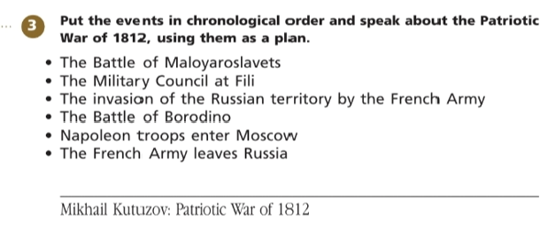

Ex. 4. Match the words (1–9) from the text with their definitions (a–i).

1. defeat
2. to flee
3. to make a decision
4. starvation
5. to force
6. supplies
7. losses
8. turning point
9. to retreat

Ex. 6. Fill in the gaps with the words from exercise 4 in the correct form. The first letter is given.
- Kutuzov _____________ a ________ to leave Moscow.
- What __________ the French Army to________ ?
- The French Army had problems with .
- The ______________ of the Russian Army was only at the beginning of the war.
- What led to the _______________ of the German Army?
- A lot of people die of ________________ in Africa.
- The ______________ of the Nazis were numerous.
- The Battle of Stalingrad was a _____________ in the Great Patriotic War.

КЛЮЧИ К ЗАДАНИЯМ.

LESSON 4. MIKHAIL KUTUZOV: PATRIOTIC WAR OF 1812

Ex. 2. Read the text again and decide if the following statements are True (T) or False (F). Keys: 1-F, 2-F, 3-T, 4-T, 5-F, 6-T, 7-T, 8-T.
1. Kutuzov was appointed the commander of the army because his rank was  higher than that of other officers. | False (F)
2. Kutuzov retreated because he was afraid to lose the battle with Napoleon. | False (F)
3. The Battle of Borodino was very important for the Russian Army,  despite the losses. | True (T)
4. Leaving Moscow and evacuating the Muscovites turned out to be the  right decision. | True (T)
5. The French were warmly welcomed by the Moscow citizens. | False (F)
6. The Battle of Maloyaroslavets forced the French Army to leave Russia. | True (T)
7. The enemy was running out of food and supplies. | True (T)
8. The partisan movement was not important for the war. | True (T)

Ex. 3. Put the events in the chronological order and be ready to speak about the Patriotic War of 1812, using them as a plan.
Keys:
- The invasion of the Russian territory by the French Army;
- The Battle of Borodino;
- The Military Council at Fili;
- Napoleon troops enter Moscow;
- The Battle of Maloyaroslavets;
- The French Army leaves Russia.

Ex. 4. Match the words (1–9) from the text with their definitions (a–i).
Keys: 1-i; 2-e; 3-h; 4-f; 5-b; 6-d; 7-g; 8-c; 9-a.
1. defeat | i. to win against somebody
2. to flee | e. to run away from danger
3. to make a decision | h. to decide
4. starvation | f. extreme hunger
5. to force | b. to make smb do smth
6. supplies | d. things like as food, medication, ammunition
7. losses | g. killed and injured people
8. turning point | c. a time at which an important change takes place
9. to retreat | a. to move away from enemy forces

Ex. 6. Fill in the gaps with the words from exercise 4 in the correct form. The first letter is given.
- Kutuzov made a decision to leave Moscow.
- What forced the French Army to flee?
- The French Army had problems with supply.
- The retreat of the Russian Army was only at the beginning of the war.
- What led to the defeat of the German Army?
- A lot of people die of starvation in Africa.
- The losses of the Nazis were numerous.
- The Battle of Stalingrad was a turning point in the Great Patriotic War.

